Tips for Communicating Product/Service Ideas
through User Scenarios
Pick a core scenario that describes how someone will use/interact with your proposed solution. Tell the story from beginning to end:
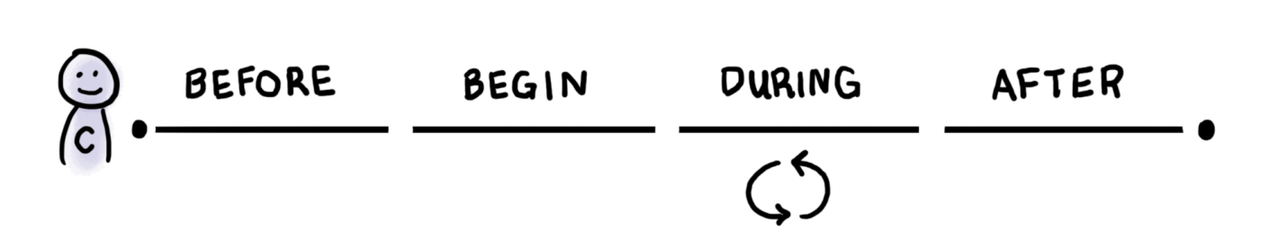
Source: https://blog.practicalservicedesign.com/understanding-the-lifecycle-of-service-experiences-33b29257f401

When developing scenarios to express how your group’s solution(s) will work, consider at each step:
- What is happening from the user’s perspective (i.e. the front stage)?
- What operations, people, rules, and processes happen behind the scenes in response to actions the user takes (i.e. the back stage)?
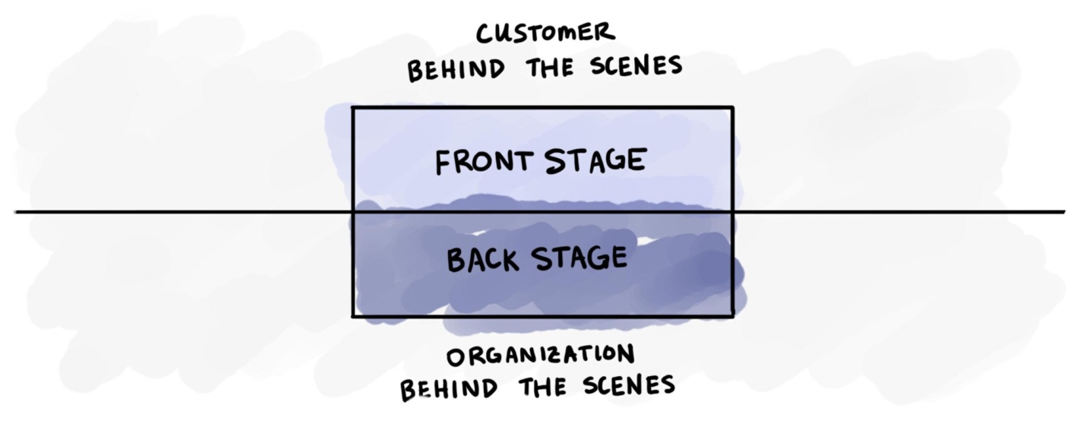If you imagine a simple stage in a theater, the front stage is where the action happens and what the audience can see; for us, customers act on the front stage.

The backstage is where all the support processes live that produce the front stage, the lights, the sets, the crew, all of which should be invisible to the customer, but often isn’t. The backstage is us, the organization and all the things we do to make that front stage happen.

Then there is the behind-the-scenes, where all the intangible things that the organization must do to make both the front and backstage possible. Rules, regulations, policies, budgets; all the things that aren’t really a part of either the front or back stage.

Source: https://blog.practicalservicedesign.com/understanding-the-lifecycle-of-service-experiences-33b29257f401

Questions to help guide discussion and develop scenario ideas
- How will people hear about or discover your product/service?
- What can they do to learn more about it?
  - How will they know where to go for that information?
- How can people purchase, signup or get involved in your solution?
- How will they new users know/learn how to get the most out of your product/service?
- What are some barriers or things that can go wrong while people use your product/service?
  - How does your solution respond in these situations?
- What happens when someone decides to quit using your product/service?

NOTE: Don’t focus too much on the figuring out the finer details of how your concept will work at each step in the scenario or what it will look like. Instead, focus on communicating the essential parts that demonstrate how the service/product works and what happens at each step in the scenario. Ideally, if you place someone with no knowledge of your product/service into your scenario they should be able to figure out how the service works or know what to do next (if role playing the scenario).

