- Project Name: David Marsh, ‘Allendale’

- Location: Boorowa, South West Slopes of New South Wales, South East of Australia

- Short Introduction:

A 814 hectare property⁽¹⁾ that has been with this owner/manager 50 years. Originally prize winning high input - high intensity cropping, wool, lambs and beef. A severe drought in 1982 triggered a decade and a half of soul searching, research and consideration of other approaches. No real changes made until late nineties.⁽¹⁾ Attendance at a Holistic Management course inspired ‘a frank ‘gross profit analysis’ … of overheads an enterprise covers in relation to its costs.’ ‘Marsh saw for all the impressive churn of money that cropping entailed, across the years the enterprise wasn’t nearly as profitable as he’d thought.’⁽²⁾ ‘Debt is an escalating issue for the Australian farm sector.’ Marsh dealt with this creatively, ‘throwing off the enterprises that (that were) unsustainable’ ⁽²⁾

Today the enterprise has been simplified to run just beef cattle and yet still achieve equivalent profits.

- Photo:

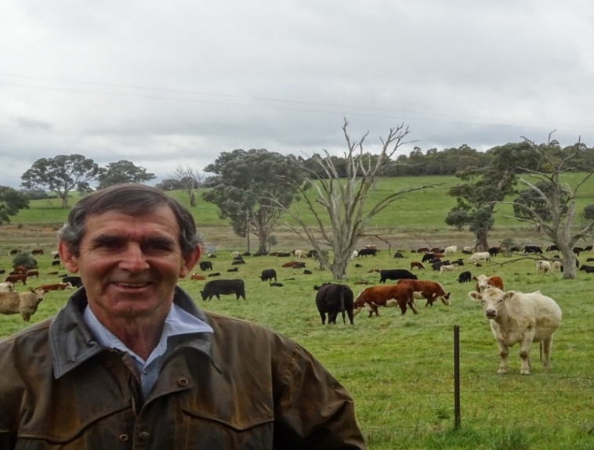

- Main Challenge: ’Badly hit by the drought of 1982, a by-product of the strongest El Nino event yet recorded. Country was denuded and then in 1983 29mm of rain fell in 20 minutes resulting in the loss of good top soil. This episode caused much soul searching about their approach to farming.’⁽¹⁾

‘As he shoveled grain and mounting debt into hungry sheep, raising plumes of blowing dust, Marsh found himself shamed by the state of the land and his responsibility for that state. He vowed it wouldn’t happen again.’⁽²⁾

- Changes Made: Marsh ‘flirted with change for 15 years after 1982, without making large shifts on the farm.’ ‘He actively scouted for new ideas, and tested a few.’⁽²⁾ A succession of the journey follows.

- Tree Planting. Tree planting started in earnest after the 1982 drought. This coincided with involvement as President of Boorowa Landcare.⁽¹⁾ (20 % of the property is now dedicated to trees).⁽¹⁾

- Whole Farm Planning. Adopted whole farm planning in 1989.⁽¹⁾ Also met interesting people from this period and read important books that set the compass for the farming/grazing philosophy that was to unfold:

People: Andrew Campbell (Founder of Landcare); Alan Savory (Holistic Planned Grazing); Basil Baldwin (University of Sydney academic who conducted saline soil research on the property for several years); Terry McCosker of Resource Consulting Services (RCS).⁽¹⁾

Marsh credits a couple of (books) in particular with more firmly rooting his farming in ecological concepts: Aldo Leopold’s 1949 classic A Sand County Almanac and Eugene T. Odum’s Basic Ecology (1983)⁽²⁾

Others include: Mary White’s The Greening of Gondwana; Alan Savory’s Holistic Management; Alistair McIntosh Soil and Soul; Fritjof Capra The Web of Life; Rachael Carson and her books The Edge of the Sea & The Sense of Wonder; Vandana Shiva Monocultures of the Mind; and Pimental Pimental Food, Energy and Society. Also numerous books as part of his studies for a Masters in Sustainable Agriculture degree through the University of Sydney (Orange campus) completed in 2001.⁽¹⁾

- Holistic Management training. ‘But revolutionary change only began in the late 1990s’⁽²⁾ after David completed a Holistic Management course based on the Alan Savory’s writings. This is ‘training in a way of thinking which tries to balance social and economic imperatives with the future landscape function’⁽³⁾ Changing took a while but this course set the direction for the emergence of a different land use regime on Allendale. ‘Like many farmers since, Marsh was impressed by the logic.’⁽²⁾
- Holistic Management assessment. ‘The Holistic Management process involves a frank ‘gross profit analysis’ This assesses the percentage of overheads an enterprise covers in relation to its costs. It’s a crude but effective exercise. Marsh saw for all the impressive churn of money that cropping entailed, across the years the enterprise wasn’t nearly as profitable as he’d thought.’⁽²⁾

- Matching stocking to feed levels. During the drought of 2002-2010, ‘If pastures got run down stock got sold. No feed was brought in.’ ‘We had to fall out of love with our animals’ and ‘adopt the attitude that growing plants and biodiversity were our business’ ‘Rigorous feed budgeting ensured stock left the property months before feed levels got critical – and months before the livestock market dived on drought induced-panic.’⁽⁵⁾ ‘Sometimes, as in 2006, that means selling nearly everything.’⁽²⁾

- Infrastructure to keep as much as possible of the ground cover in paddocks at all times. After trading livestock to ‘maintain financial status quo’ (during the drought), Marsh ‘invested in long-term capital works like fencing and new watering points.’⁽⁵⁾ ‘He diverted a couple of years of fertilizer and chemical budgets into a program of sub-dividing his 26 paddocks (into 94 paddocks) so he could better manage plant recovery after grazing.’⁽²⁾ He also laid 26km of 2.5 inch pipes to deliver water. Development occurred over 5 years and cost was estimated at $85/hectare

- Stock management to optimize ground cover. ‘Now we want animals to stay on land for only the time they don’t damage the plants, only a few days. The big thing is the movement of animals is dictated by the rate of growth of plants.’⁽⁴⁾ ‘In slow-growth periods of the year, Marsh allows pastures 120-180 days of recovery from grazing. In severe drought, pastures have sometimes gone 240 days between visits by livestock.’ ‘Long periods of recovery allow highly palatable species, which might otherwise be grazed into oblivion, to grow and set seed.’⁽²⁾

- Axing costs. ‘A simple illustration of how ruthlessly costs have been pared: Allendale doesn’t have a tractor. It’s a big chunk of capital and ongoing cost that Marsh can live without. When he needs a tractor .. he hires one from nearby.’ ‘Another axed cost: no fertilizer. Marsh isn’t against fertilizer per se but, he says, ‘We seem to be able to grow as much or more pasture without it’.

- Philosophy. Mr Marsh is convinced of the benefits of maintaining the biological complexity of his property as a hedge against dry times. ‘Look after the land and it will look after you’.⁽³⁾

- Outcomes: Much better returns on investment have been achieved via David’s reduction in input costs (and thus lower debt, stress and operational pressures). The natural capital and equity value of the property has risen significantly, much more than any increased profits that could have been made by extractive high intensity/high input grazing systems.

Economic. During the 2002-2010 drought, ‘Allendale saved an estimated $ 500,000-$750,000 in feed costs. The property did not go into debt during this period like many other farms. Stocking rates are now back (to where they were before the drought) to 11 DSE/ha, around ‘620 breeding cows on 700 hectares.’ ‘When he was pushing hard in a conventional system … the property peaked at 12 DSE/ha.’⁽⁵⁾ So now with no inputs resulting in no outgoings, profit is greatly increased.

Instead of technology, the Marshes are employing biodiversity. ‘We spend so little that it is a bit embarrassing’ ‘And it’s terrifying to look back through the books to see how much money we were spending.’ ‘For the Marshes, it has meant more security – not because they are making more money, although that can happen, but because they almost never lose it. And that it largely because they don’t spend it. (But) this isn’t a description of genteel poverty. The couple travel overseas. They drive good vehicles. Life isn’t pinched, partly because farm costs have been.’⁽²⁾

Social. ‘Marsh originally had several enterprises on the go at once – cropping, wool and lambs, cattle. Now he has one, cattle. The holistic approach has taken some of the stress out of farming and been the Marsh family avoid the debt spiral that (so many) drought stricken farmers have had to endure.⁽³⁾ The satisfaction of not losing ground cover and the financial consequences of not increasing debt.

‘The farm’s operation has been so greatly simplified, and so much placed in the capable hands of nature, that it is no longer necessary to be hands on from dawn to dusk. Marsh is still gnawed by a small sense of sin over this. He’s a farmer, and physical work is the farmer’s identity (but) he has loved his quest for understanding over the past 16 years, reading and now writing⁽²⁾

Further, ‘the half hour that Mr Marsh spends moving cattle between paddocks is sometimes all the work he needs to do in the day.’ This is ‘a result of shifting responsibility for farm productivity from people to nature’ “Instead of trying to bend nature to our will, we’re trying to fit in with the way the world works”⁽⁵⁾ Extra time has meant extra thought on the ethics and philosophy of how people relate to the land and more time to devote to the community.⁽²⁾

Ecological.

Increased natural capital value is reflected in biodiversity improvements. The land and operations have much higher resilience and capacity to buffer and avoid the climate extremes that are still crippling neighbors.

Research by the University of Sydney found ‘The soil organic carbon levels (have increased) from 1.6% to 3.5% .. (even) .. during an exceptionally dry decade.’⁽²⁾ ⁽⁶⁾ They noted ‘all the benefits that brings’, including ‘greater water holding capacity, better moisture conductivity, greatly improved soil structure, improved nutrient cycling, more soil life .. and the list goes on.’⁽²⁾
The holistic grazing regime assisted greatly in reducing the impact of soil salinity.⁽¹⁾ The distance between perennial plants has decreased⁽¹⁾ and ‘Some paddocks host up to 59 species of plants in their pastures, including 15 natives. Fifteen years ago, many paddocks carried just one species: a cereal or oilseed crop.’⁽⁵⁾ ⁽⁶⁾ No chemicals have been used for 17 years (since 1999).⁽¹⁾

‘At last count, 125 bird species inhabit the grasslands and extensive patches of bushland the Marshes have planted.’⁽⁵⁾

- Critical management moments

- ‘Doing the Holistic Management course demonstrated the importance of ecology. In the 1970-80s David was too busy farming to read and reflect and realise the importance of ecology.’⁽¹⁾

- Being able to talk with others, read books about ecology, and reflect are critical components of change management.⁽¹⁾ ‘The sense of isolation he felt when he began moving in another direction (was) largely replaced with a sense of independent ease – particularly as he is now well connected with others with the same outlook.’⁽²⁾

- And confidence has an important role to play in conjunction with reflection. His wife, Mary’s ‘involvement was an important endorsement of his decision to start tacking away from his past and the approval of the conventional farming community.’⁽²⁾

- ‘His father’s interest in birds on the farm and on composting had an impact on his direction of farm management.’⁽¹⁾

- Project Contact: ?? David Marsh
- Project Status: Fully operational
- Main Language: English
- Website, links, videos, newspaper articles:
(1) Eco Ag Interview
(2) http://goodlandproject.com.au/2015/06/david-marsh-simplicity-for-complexity/
(3) The Australian
(4) http://www.smh.com.au/environment/animals/david-marsh-thanks-allan-savoys-african-grazing-plan-for-revival-at-boorowa-20160308-gne5mt.html
(5) http://www.theland.com.au/story/3587830/productivity-its-only-natural/
(6) University of Sydney
(7) http://www.arlash.com/blog/

