OSCEdays Website 2017 Draft, Vs 1.2

General Info and what is missing:

- The Design (template) will be the same. (perfect)
- I think about changing the headline font to Open Sans? (use opensans in all the web site?)
- Where is the documentation of the past events for example the Open Labs Docu? Probably the History Page should be rebuild into “Past Events” – and be updated constantly with links to documentation.
- If the theme has a slider – we can place info about upcoming things in it. (perfect! More relevant information appearing without having to look for it much.)

_________

COMMUNITY FORUM BLOG VIDEOS SUPPORT MORE +>
pop up menu behind MORE:
CONTACT US
OUR MISSION STATEMENT
SET UP A LOCAL EVENT
HISTORY / PAST EVENTS

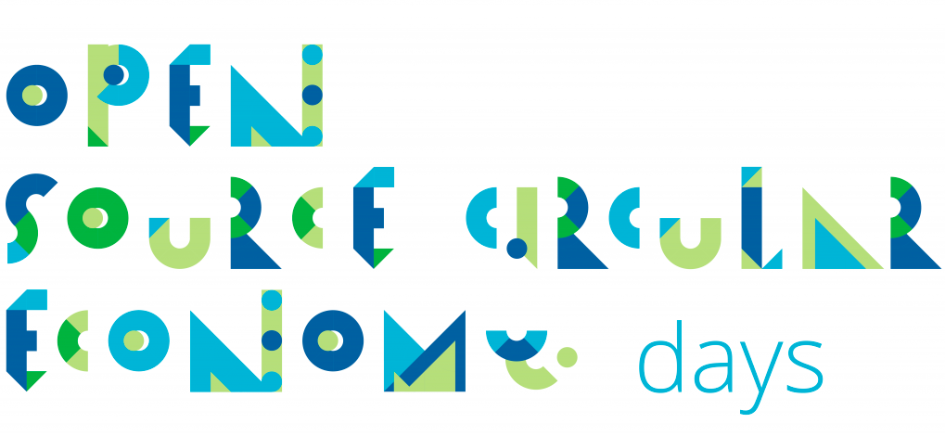

Open Source Circular Economy Days

is a global open community about open source resources to create a shift to a sustainable circular economy.

We are collecting ACTION protocols and use play with them and implement them in open events across the globe. Join us!

This gonna be the images?

take    ACTIONS  An ACTION protocol is a simple step by step guide helping people to understand and use a circular economy solution. Pick one from the list or contribute one.  Scroll down for examples  ⇓  Can we put a link than directly scroll down to this part? | run  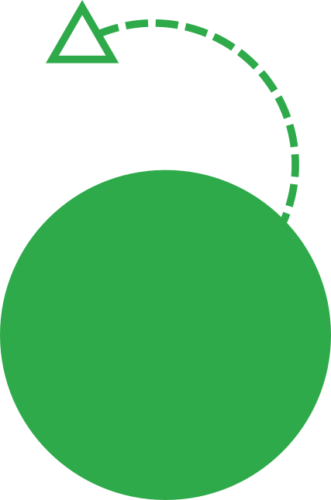  EVENTS  You can run a local event in your city – invite a local community to play with OSCEdays resources and methodologies and to connect to other parts of the world.  Scroll down for upcoming events.  ⇓ | care &    JOIN  OSCEdays is maintained by a board of stewards building and shaping the global project. You can join us or support our work as a Patreon. Think about joining?  Start with the our project Readme  ⇓

CALL TO ACTION! In this part can be used a two columns template?

UPCOMING:

OSCEdays Writers Weekends – #1: March 4 & 5

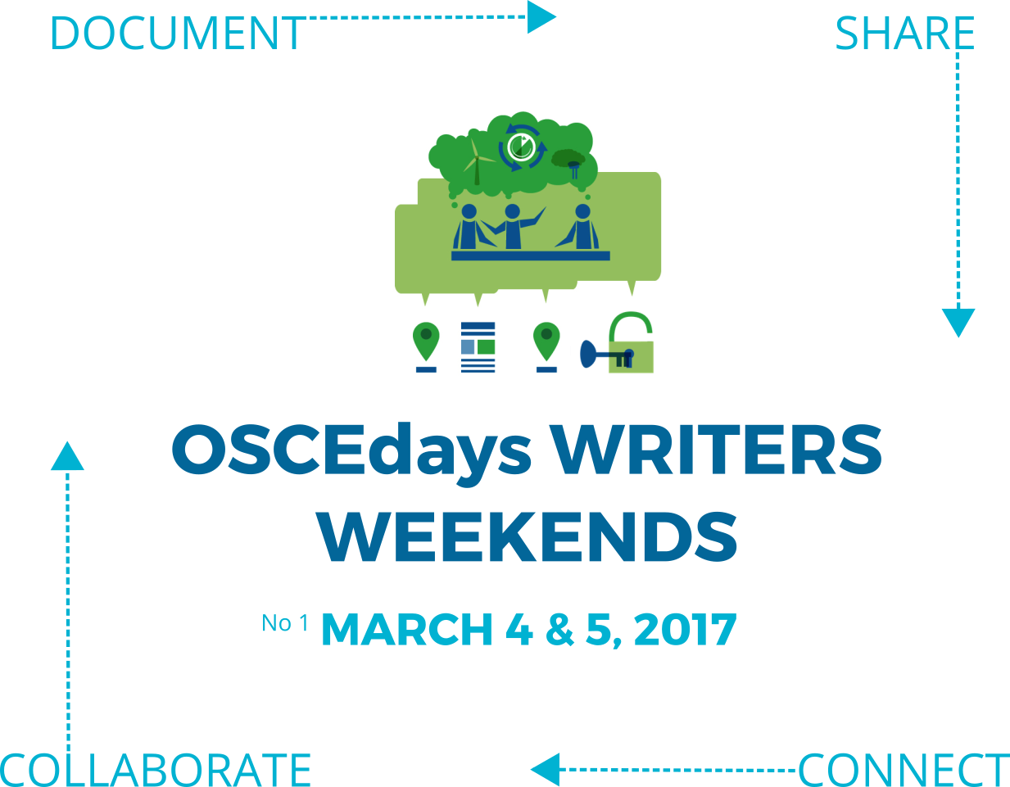

We invite knowledge people across the globe to document circular solutions and create ACTIONS – sharing knowledge and opportunities, get visible and connect globally. Join the first weekend ->

READ THE CALL!

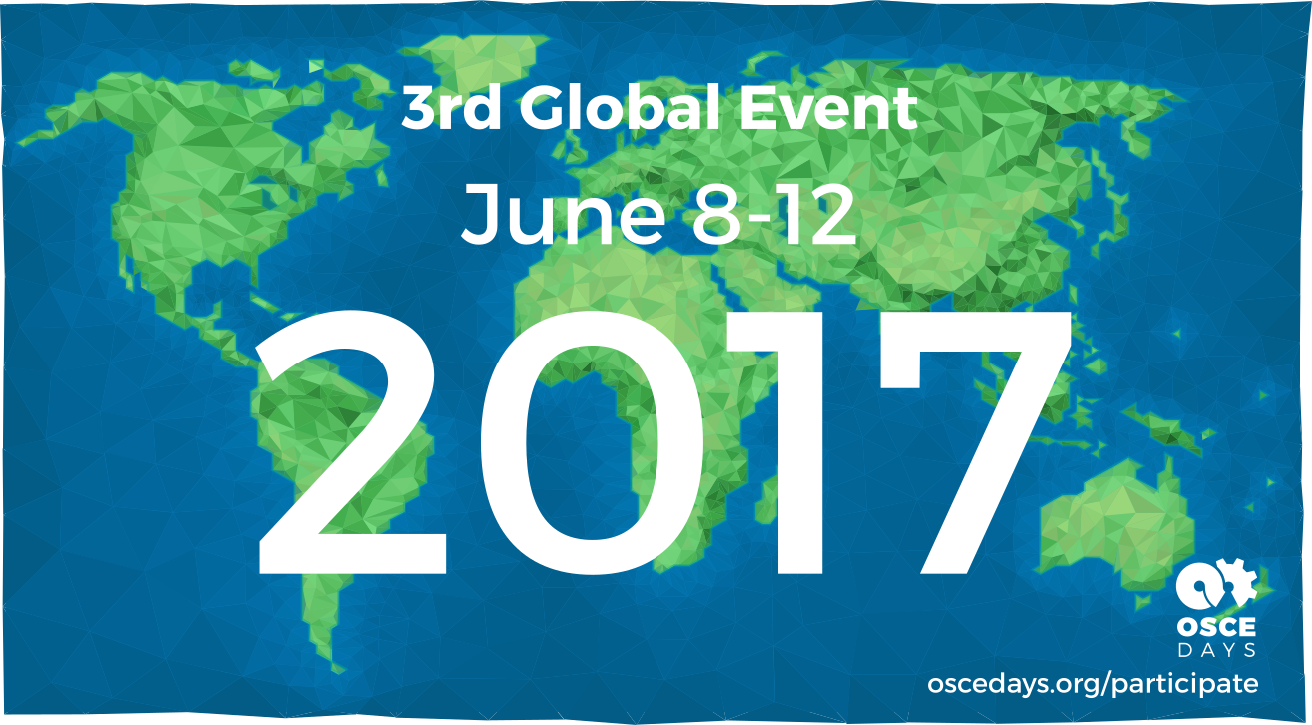

3rd Global Event – June 8-12, 2017 – Sign Up!

Following its (young) tradition we will have a global JUNE date again – inviting people from across the globe to run local events all at the same time and connect them upfront, live during they happen and also afterwards. We learned a lot from first two iterations so the event will be bit different this year.

READ MORE & JOIN US. [Link Participation Guide]

Cities on the map so far: Berlin, Indianapolis, Cape Town

Sign Up Here!

Hint to self: Use the 2 column template in between to have the images correctly sized.

NEWSLETTER

Subscribe to our Newsletter to get updates and news. You can also join us on Twitter [IMG], Facebook [IMG] and our Forum [IMG]

Email_______________ {Submit}

________

SUPPORT

You can support this global Initiative. Become a Patreon:



I do not know if it is better to place support in this part or better (before the call to action) above, as it might be confusing that support is being requested for a specific action and not for OSCED.

ACTIONS

This are step by step guides built on open source resources allowing you to learn about, play with and implement circular economy solutions. You can use them during your events or whenever you like. Use them to connect to other people. Add an ACTION.

[IMG]  Open Source Circular Economy Business Models (& Products)  A workshop methodology to understand and experiment with Open Source ideas to redesign any business and product to work circular with Openness.  By Lars2i | [IMG]  Explore, solve and document a local circular economy challenge  _ short description _  By BoST | [IMG]  Hack on Open Circular Modularity (In Dev.)  _ short description _  By Mifactori
The Circular Design Guide – Open Workshops  There is a fantastic resource … use it to …  _ short description _ | Set Up A Circle Dinner To Connect Local Stakeholders  _ short description _  by Alice Audrey Grindhammer (CRCLR Berlin) |   There are more! See the full list in our forum.  Contribute An ACTION!

Maybe the part above could be 2 columns instead of 3. It is just one click to test. 3 are ok

–

Not sure if the next part is needed anymore… – let’s discuss with BoST. (It is already there so a test is quickly done.)

Leaving only the image of the planet seems fine, I just do not know if a link can be made to each city from this image, because if the cities are erased you would lose the possibility of going directly to visit these. But it could also be better to eliminate them from here and place them on the page of past events, so that you delete so much information from the main page, and once you have a link prepared to the main event of June, from there can to be addressed to Participating cities since many of the cities do not have important information.

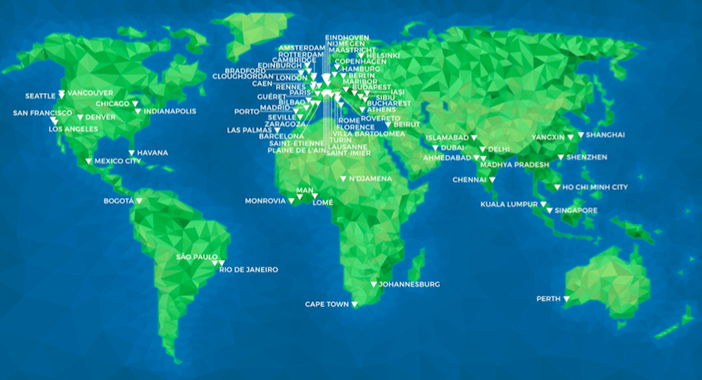

Cities  Inactive & Inactive  OSCEdays started in 2015 with a global event. See below who is been involved in the past. Learn more about our history.  City Country  City Country  City Country | City Country  City Country  City Country  City Country  City Country  City Country  City Country  City Country  City Country | City Country  City Country  City Country  City Country  City Country  City Country  City Country  City Country  City Country | City Country  City Country  City Country  City Country  City Country  City Country  City Country  City Country  City Country

Stewards

This is the group of people guiding and building the global project. The group is open. Join us.

[FACE] [FACE] [FACE] [FACE]

I am also not sure if we really need our faces on the page anymore. It could be like it is but instead of our faces there are our forum names: @gien @silvia @stasia and so on – and a link to our profile on the forum where we can share the information about us needed. An Image and so on. – Opinions?

Maybe it could be like this (because I real name is good for trust and transparency) :

@sharmarval  Sharon Prendeville | @gien  James Gien Varney-Wong | @Johnny  Johnny Kerkhof | @Frans  Frans Prins

Maybe user, name and profession?
Partners & Friends

/as is except the headline /

___

‚Support on Patreon’ button also into the widget area at the bottom of the page.

