Maker Walk

# How to do a Maker Walk

# 1st Draft

 [rdm](http://www.rdmrsc.org.uk/) Logo of the EPSRC, the Engineering and Physical Sciences Research Council Bristol uni

# What is a Maker Walk?

A Maker Walk involves exploring, by foot, a neighbourhood to identify, chat with, and map makers and manufactures.

The very act of walking and visiting local makers provides a unique insight into what is been made in your neighbourhood, by whom and how.

# What’s in this Maker Walk Guide

This guide is based on our experience of undertaking a Maker Walk in a Bristol neighbourhood. We hope this guide will be a useful resource to inspire you to do your own Maker Walk

Why do a Maker Walk? 3

How to set up a Maker Walk 3

Tips While out on your Maker Walk 9

Open Data Kits (ODK) 11

## 

For the purpose of this document all manufacturers and makers are named ‘makers’.

# Why do a Maker Walk?

Building relationships with local businesses is notoriously difficult. A Maker Walk provides an opportunity to **go out and meet local makers** and build a deeper level of engagement with local communities.

#### Challenge 1: Makers, especially small scale and traditional ones, are frequently bad networkers. They often work in isolation or keep to their established supply chains. Small makers tend to not have an active online presence. As such they can be difficult to find, let alone establish what manufacturing capabilities they possess.

#### Challenge 2: Despite numerous company directories and national studies, it is impossible to obtain an up-to-date and comprehensive list of makers within a city. As a result, it is difficult to gain valid data and insight into what is being made in the city, by whom and how?

Although anyone can undertake a Maker Walk: Here are the main reasons some of our current partners joined our Maker Walk.

## Museumsto document a city’s industrial and social activity for future historical archives.

to bridge the gap between visitors and the local industrial ecology.

## Makerspaces to broaden the making capacity beyond the walls of the Makerspace.

to engage with professional makers thus strengthening the local economy.

Academic Researchers to gain in-depth knowledge of local & urban manufacturing.

to build collaborative projects with typically hard to reach manufacturers.

## Policy Makers to gain insight into the importance, scale and type of manufacturing that is occurring in a region enabling better informed and evidenced policies to be made.

## Studentsto see the important contributions manufacturing makes to a city.

to experience the variety of local making based enterprises and entrepreneurs.

Artists to explore an urban landscape and the integration of making into the city.

to develop connections and relationship for future collaborations

# How to set up a Maker Walk

Answering the following questions will help determine the best Maker Walk approach for you

#### Questions to ask before planning your Maker Walk

##### Why do you want to do a Maker Walk?

##### What geographical area do you want to cover on the Maker Walk?

##### What do you consider to be manufacturing or making?

##### Are there any particular makers you are specifically interested in?

##### What information about making do you want to collect?

##### What do you want to do with this information at the end of the Maker Walk?

##### Who will you be doing the Maker Walk with?

##### When can you do the Maker Walk and for how long?

##### Are there any local organisations who have strong connections with local manufacturers? Will they be willing to collaborate with you on the Maker Walk?

##### Are they any local organisations who would benefit from joining the Maker Walk?

##### Do you want to inform makers that you will be calling into them or do you want to cold call without any prior warning?

##### How much time and how many people do you have available to do the Maker Walk?

### Maker Walk Team

The first action to take when planning a Maker Walk is to set up two teams. The first, the **‘organiser team’,** will set out the Maker Walk objectives. This team will plan the walk and set up the tools for the Maker Walk. The second team, the **‘walking team’**, will do the walking, talking and information recording. These may turn out to be the same people if there are only a few people involved in your Maker Walk. It is best to decide the teams before you make any major decisions, as the capabilities of your ‘walking team’ will determine how you undertake your Maker Walk.

Each ‘walking team’ should consists of three but no less than two people. This is primarily for safety reasons so there is never a solo walker. It is best one person does the talking (**the interviewer**) while another person records the responses (**the data recorder**). You should always request permission before recording anyone.

Some possible walker roles are as follows:

**Walking Team**

#### Interviewer introduces the Maker Walk and asks the questions

#### Data Recorder notes the responses the manufacturer gives to the questions

#### Photographer/Videographer records the makers, visual industrial landscape and/or the Maker Walk itself

#### Social Media Communicator provides updates as the Maker Walk unfolds

### List of Companies

While trying to find makers in your area can be a difficult task, so it’s best to prepare a list of makers in advance. This will help you plan the walking routes and will ensure you don’t miss registered companies.

A list of companies can be found from a wide range of sources however there are many barriers to access these sources, such as data protection, paywall, data formats etc. A good starting point is Company House and Fame Databases, which are frequently accessible through Universities and libraries. These provide a search option for companies registered under manufacturing SIC codes SIC2007 10-33 with headquarters or operational units in your neighbourhood. While these databases provide an array of information, only the name and address of companies’ is required for the Maker Walk.

### Leaflet, Business Card & ID

When out on the Maker Walk it is best to have some form of ID such as a business card. This will help confirm who you are or who you represent. Likewise, an informative leaflet provides an opportunity for the makers to find out more about your Maker Walk as well as an opportunity to contact you at a later date.

### Data Collection

#### Keep the data simple

The type of information you collect depends on the type and purpose of your Maker Walk.

We believe it’s best to take an open data approach to the Maker Walk. This means that all the non-sensitive information you collect can be openly shared. We found that many people were initially hesitant to talk to us but once we explained we only required a quick response to three simple questions they generally opened up and chatted freely.

**Our Three Maker Walk Questions**

*Do you manufacture/make anything here?*

*What do you manufacture/make?*

*How do you manufacture/make? (i.e. processes & materials & tools used)*

There is a vast array of additional information you can collect on you Maker Walk, such as photographs, sounds, noise levels, air pollution etc. If you want to collect sensitive information such as financial performance, supply chain, employee details etc. you should ask each maker to sign a consent form, but bear in mind this may restrict who is willing to talk to you.

#### Data collection tools

How you collect the information on your Maker Walk depends on what you want to collect. We decided to use an android tablet that had a Global Positioning System (GPS) chip to record our location and maker responses. This greatly reduced the time spent inputting the data into a computer after the walk. We also wanted to track the Maker Walk route and the exact location of each maker. Open Data Kits are free and a great research tool that you can install on android devices to conduct field research (see the ODK section of this guide).

#### Research Methods

If you want to conduct a research based Maker Walk you need to ensure everyone follows the same process, asks the same questions and records information in the same format. In our Maker Walk this consistent approach helped to highlight inconsistencies between existing data and what making is actually taking place in the neighbourhood.

### Interview Script

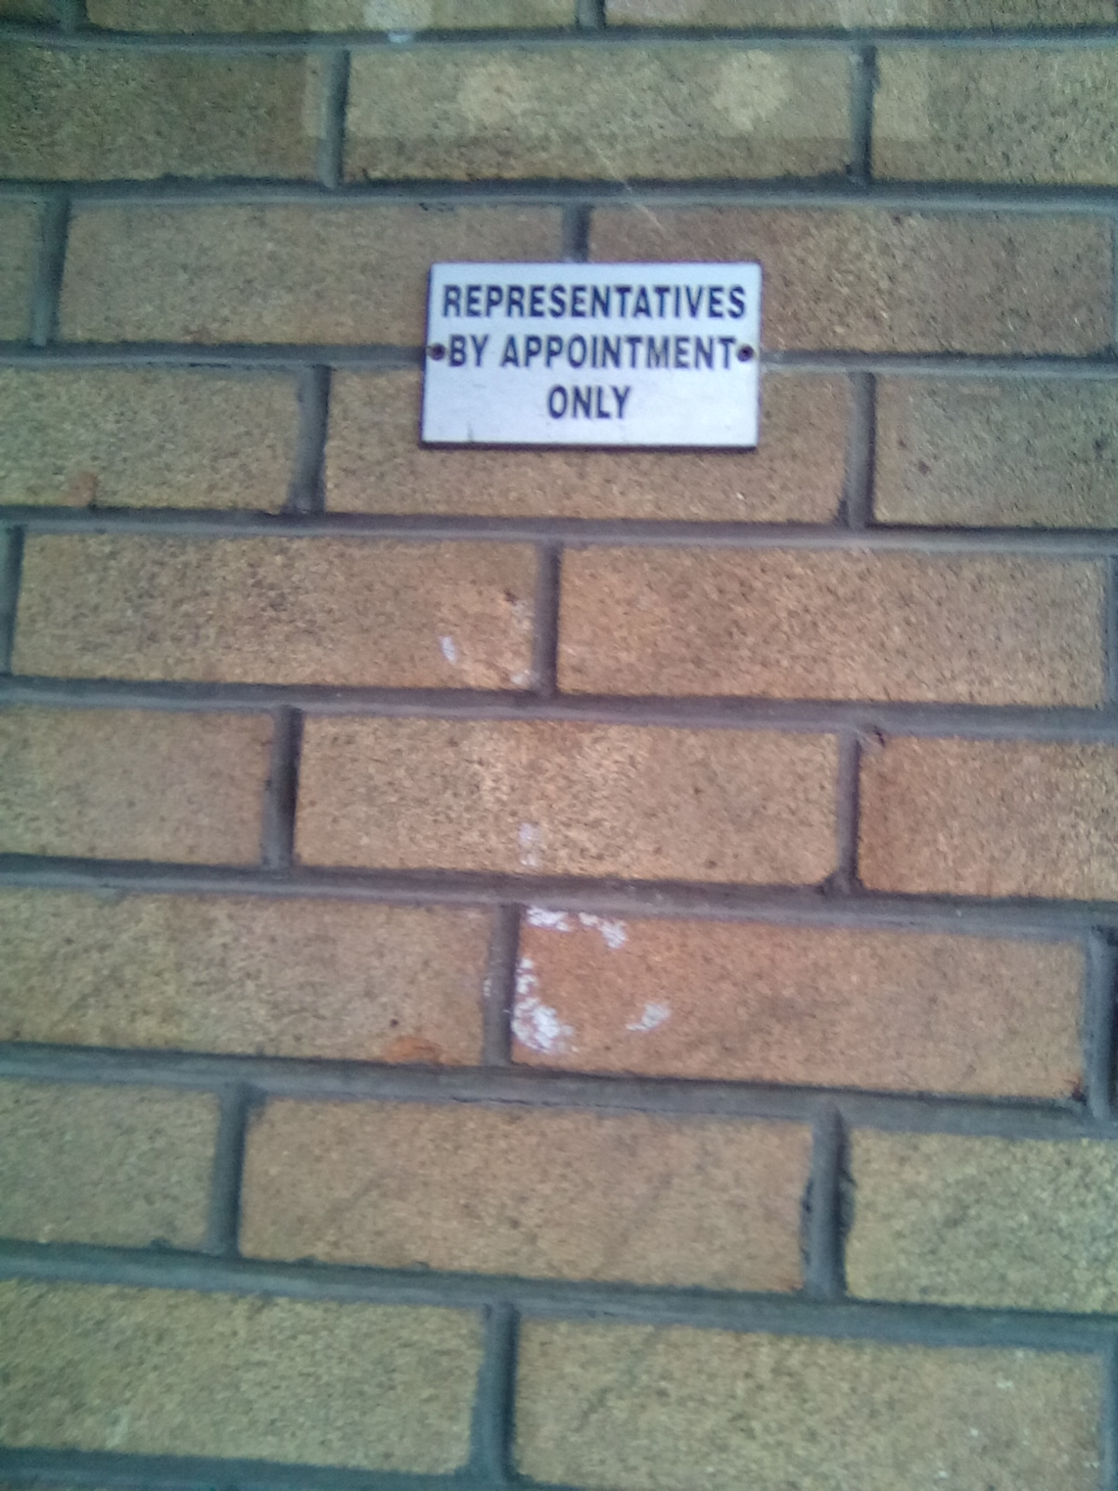One of biggest challenges of the Maker Walk will be your initial interaction with a maker. You need to make the first minute of conversation to be succinct and prompt. Don’t be discouraged by intercoms, dismissive receptionists with a prepared interview script.

It is best to prepare a two phase script.

A **quick introduction script** for an intercom or receptionist, such as

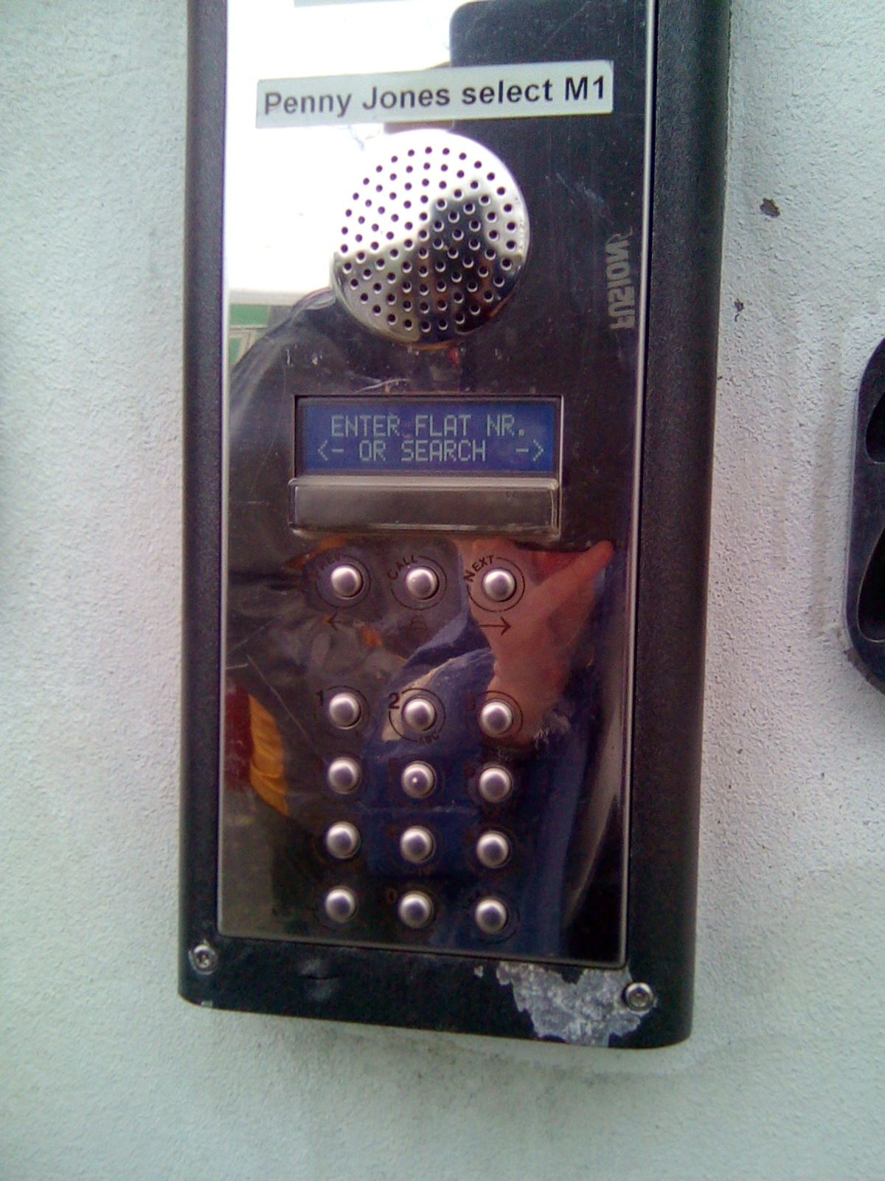*“Hi, we are a team of researchers from the local university trying to find local manufacturers. We would like to find out if you manufacture anything here and if you or a colleague can answer three simple questions”*



You should than prepare a **longer script** including a description of your Maker Walk, why you are doing it, and your interview questions.

We found that asking people if they had ‘time’ to answer some questions always got a negative response. In the working world who ever has time! So instead try to weave your questions into a conversation rather than using a formal or dry interview style.

When cold calling to companies you will find most people initially react with confusion and a few may be suspicious. Additionally, very few people you meet will have much time to discuss any issues in detail. Although a prepared script will give you an indication of what to say in the first minute, it is not always advisable to follow it exactly. You should leave some leeway to tailor your conversation to the specific company you are talking to. This will enable you to build a natural rapport with the maker.

We recommend you trial the interview process with a few different people. Role playing out different scenarios will give you a whole new set of questions a maker might ask you.

It is also very important that you inform the companies where all the data you collect is going to be stored and shared.

### Trial Maker Walk

Once you have your ‘walking team’ selected, roles assigned and data collection methods agreed it is time to do a trial Maker Walk. We recommend you try out all your equipment on a dry run before calling to any companies.

A trial walk will give you an indication of the following:

* how much area you can cover with your ‘walking team’ within time available
* if your data collection tools work as expected
* if all the ‘walking team’ members are comfortable with their roles

This will help you decide if you need to how your approach to the Maker Walk

### Routing

It will be much easier to plan your Maker Walk route after you have complied a list of makers and trialled your Maker Walk approach.

We used [OptiMap](http://gebweb.net/optimap/) to create a walking route around multiple locations. With Optimap you can copy and paste multiply points into one route (whereas google maps restricts the number of points to 10). It’s best to print out these routes with a list of the makers and their address so you can tick off each maker as you go along.

We recommend you leave 15 minutes to talk to and record data from each company on your list. [OptiMap](http://gebweb.net/optimap/) will calculate how long it can take to walk the route but its best to double this time to allow for toilet breaks, coffee rests and lunch breaks. Additional time will also be needed if you are taking videos, photographs or recording other types of information.

On average we found that each ‘walking team’ was able to talk to up to twenty companies in a day. If you are only covering one small area such as an industrial estate and/or if you have a large group of walkers, you may be able to complete the Maker Walk in one day. If this is not possible we recommend doing no more than two Maker Walk days in a row. Not only does this give you time to rest between walks, it also gives you time to reflect on the findings. You may also need to re-plan routes regularly thus having an extra day between walks facilitated this re-routing.

# Tips While Out On Your Maker Walk

### Art of Conversation

Conversing with local makers will be the most rewarding part of your Maker Walk. However, you should be aware that your Maker Walk may not be of interest or of importance to some people you meet. You should can however gauge someone’s openness by trying to find what they are interested in talking about. Regardless of how others behave you should always be courteous and friendly.

### Timing

Manufacturers will have limited time to talk to you. The following insights from our Maker Walk may assist you in finding the right time to approach a company.

##### **Type of business:** Food manufacturers traditionally start earlier and close earlier than other manufacturers.

##### **School time:** Smaller makers may offer parents flexibility in dropping children to and collecting then from school. This may mean less people are available at these times.

##### **Job completion**: Towards the end of the day and the end of each week we found that many makers had tight deadlines to meet and were less open to having a conversation.

##### **Lunch time**: From a courteous perspective its best not to disturb people during lunch.

During our Maker Walk we found a much higher and more positive response between the hours of 9am and 3pm due to the reasons stated above.

### Always Keep Your Eyes Open

The pre-planned routes you created should act as rough guide for you but you should be flexible and keep your eyes open hidden makers. You never know what ‘world of magic’ lies hidden behind walls.

##### **Look Inside:** We found a lot of manufactures on industrial estates often leave their roller doors open while they work. By being discreet you can see what they do inside.

##### **All in a Name:** Many companies’ names describe what their businesses do, especially for printers, furniture or window makers.

##### **Spaces & Sizes**: Making and manufacturing often requires more space than office based activities. Keeping an eye out for large buildings or interesting buildings may unearth some hidden makers.

##### **What is Manufacturing:** Manufacturing can incorporate so many different activities. It is best you choose what type of making you are looking for as you could end up mapping cafes, retailers, bakeries or garages.

##### **Bring it Home:** Do you want to look into making taking place in people’s homes? We came across some makers registered at residential homes but found the experience of cold calling to people’s homes quite intrusive.

##### **Listen Closely:** Not one of the makers we found made loud noises, at least not louder than the passing traffic. However, by listening closely to some buildings we did notice there was some movement taking place inside which encouraged us to knock on doors we would have otherwise passed by.

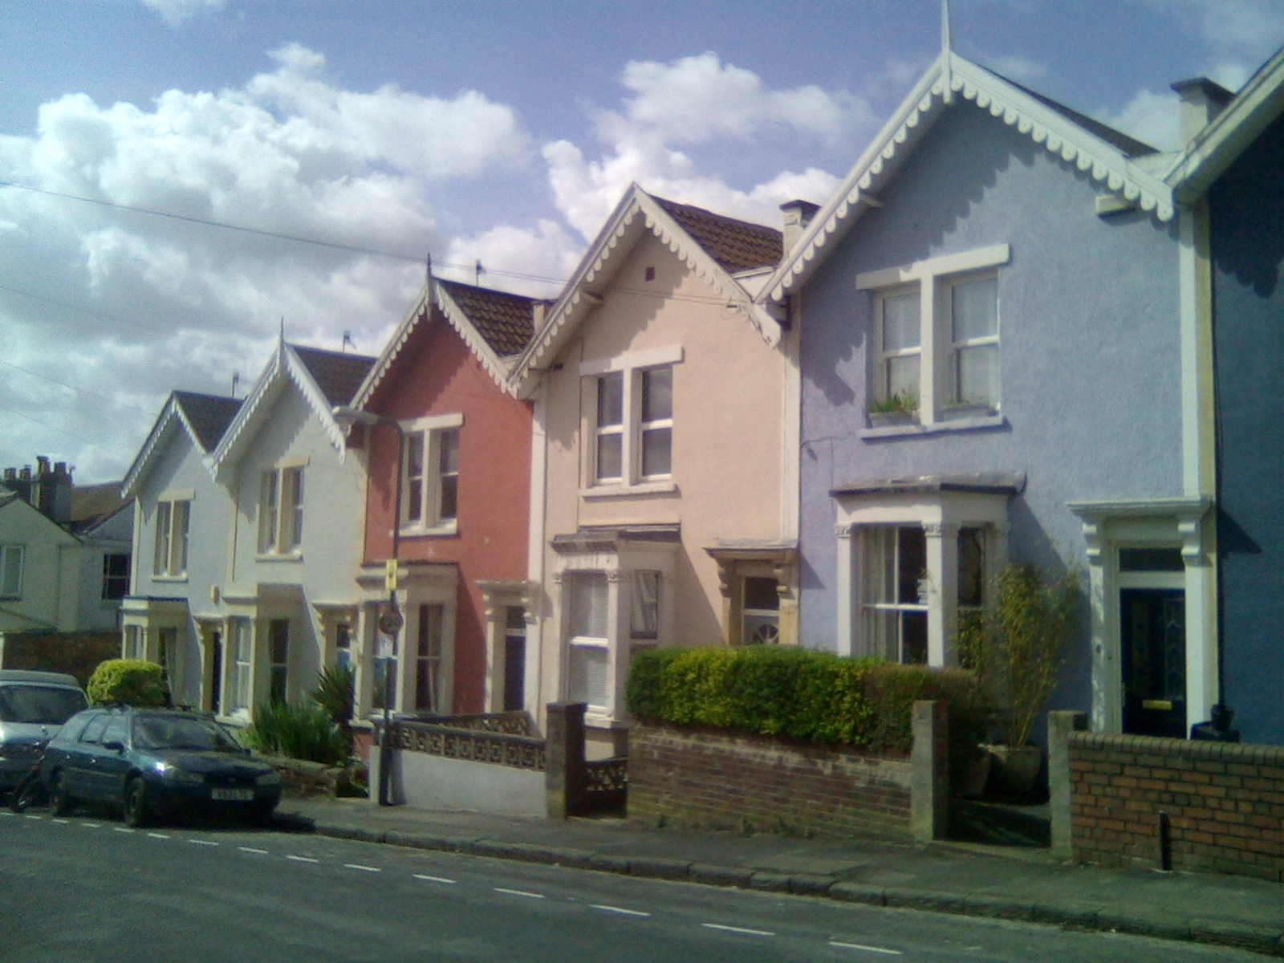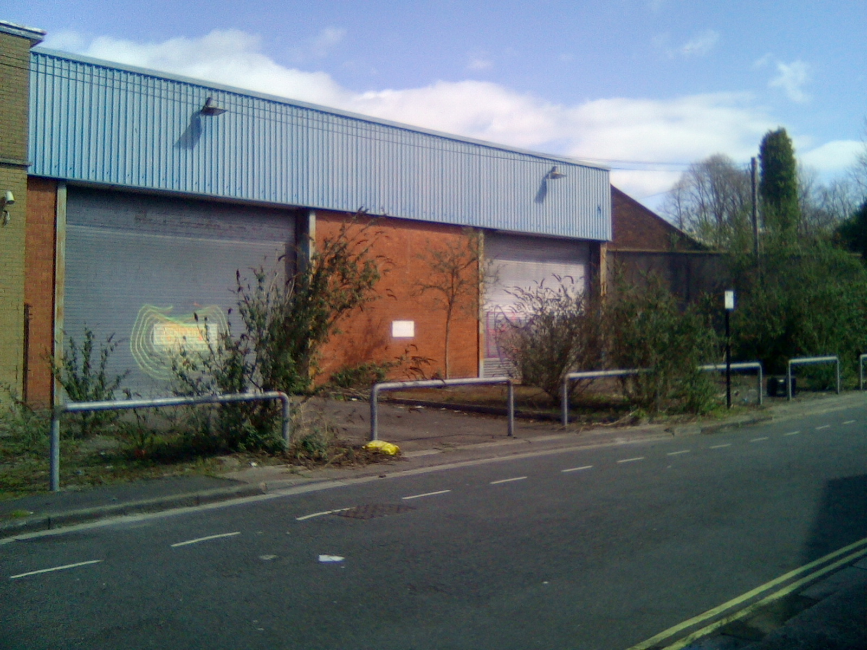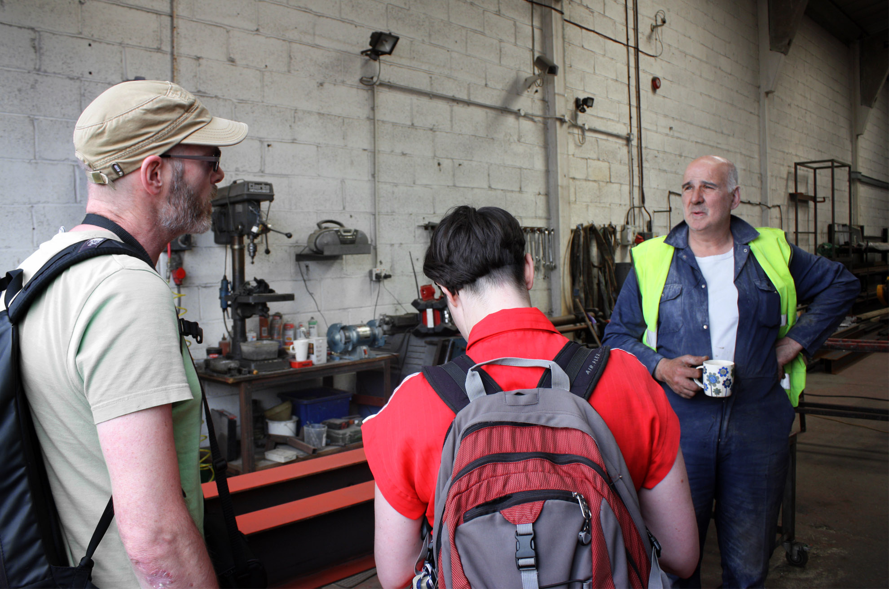

### Weather & Comfort

Unfortunately, in the UK it rains a lot! We did try a walk in the rain but found it just wasn’t feasible. Arriving into the reception area of a company wet did not create a great first impression. Not to mention the risk of water damaging equipment.

Make sure to bring the correct clothing for the weather, along with sun protection, water and some snacks. Try to wear comfortable walking shoes as you will be standing and walking for long hours. We found that we worked best with a mix of backpacks and courier style bags to make it easier for taking equipment in and out.

## Post Maker Walk

When your Maker Walk is over, and you have taken a well-deserved rest, you need to finalise what you do with all the information you collected. This really depends on the reason you undertook the Maker Walk and what information you collected. We believe that making the data open will benefit you, the local makers and your city.

If your Maker Walk was a gateway to build relationships with local makers you should follow up with them by thanking them for taking part in your Maker Walk, as well as share your Maker Walk results.

# Open Data Kits (ODK)

[ODK](https://opendatakit.org/help/form-design/) is an open source research tool that enables you to digitally collect information when out outside. It works on android mobile devices such as a smart phone or tablet.

Setting up ODK correctly will enable multiply ‘walking teams’ to collect the same type of information at the same time from lots of different locations. The information collected from each ‘walking team’ can be uploaded into one online depository. This information can be accessed by a select group of people or can be opened up publicly. Different types of information can be collected such as GPS locations, photographs, videos, audio recordings and typed answers to survey questions.

ODK consist of three key programmes

##### ODK Build creates the Maker Walk survey (information collection) forms

##### ODK Collect collects the information when out on the Maker Walk

##### ODK Aggregate places all the collected information in one place

ODK was created by [University of Washington's Computer Science and Engineering](http://cs.washington.edu/) department and members of [Change](http://change.washington.edu/).

### Helpful ODK Instructions

To help you get a better understanding of how to use ODK you should watch these instruction videos [1](https://www.youtube.com/playlist?list=PLRRSiEabNvxtzLqIKlMOQaTByxH-REEuM) & [2](https://www.youtube.com/watch?v=ceEC9RZiIiA&nohtml5=False). And read these [instructions](https://docs.google.com/document/d/1RjY_KImZbXZchyPeinLXXrqvm_laHzTVYK5yzl6kvPM/edit?hl=en).

### ODK Build

[ODK Build](http://build.opendatakit.org/) is an online tool you can use to create a survey template. This is the survey the ‘walking team’ uses to collect information when out on the Maker Walk. ODK Build is easy to use as you can drag and drop different style of questions to create a survey to suit your needs.

We split our Maker Walk survey form into three sections and separated out the information to be collected:

##### before entering a company

##### when talking to a maker

##### when you step outside the company

You can save your survey as you build it and return to it at a later date and when it’s ready you can export it as a xml file. You can use our pre-made form and alter it to your requirements by uploading the xml into OKD Build. The finalised xml file then needs to be placed on to an android device and into the ODK Collect App (explained in the next section).

If you want to build a more complicated form here are some [instructions](https://opendatakit.org/help/form-design/),

### ODK Collect

[ODK Collect](https://opendatakit.org/use/collect/) is the android app that you can use to fill out your survey from while out on your Maker Walk. Here are the [instructions](https://www.google.co.uk/earth/outreach/tutorials/odk_collect.html) for using ODK Collect.

ODK Collect can be used on any android device but not on other software like laptops or Apple devices. With ODK Collect you can automatically mark the GPS location and take photos on each survey. Therefore, each android device should have a GPS chip, a camera and preferably a SIM card with a mobile data network (3G or 4G). Alternatively, you can use a mobile data network enabled Wi-Fi router.

There are a variety of ODK Collect apps such as Geo Data Collect created by [The Humanitarian Open Street Map Team](https://hotosm.org/updates/2016-02-01_geo_data_collect_mobile_data_collection_and_tracking). This app will also track the route your ‘walking team’ followed which can help you avoid repeating the same route and visiting the same companies.

Transferring your survey into ODK Collect can be done in two ways. You can physically connect your device to a computer and copy and paste the xml file into the following folder */odk/forms*. Alternatively, you can create an ODK Aggregate account and download the survey form directly onto your device through the ODK Collect App.

To remove data from the ODK Collect App you need to set up ODK Aggregate account. You then need to enter the ODK Aggregate information into ODK Collect. This will allow you to transfer all surveys from ODK Collect to ODK Aggregate through a Wi-Fi connection.

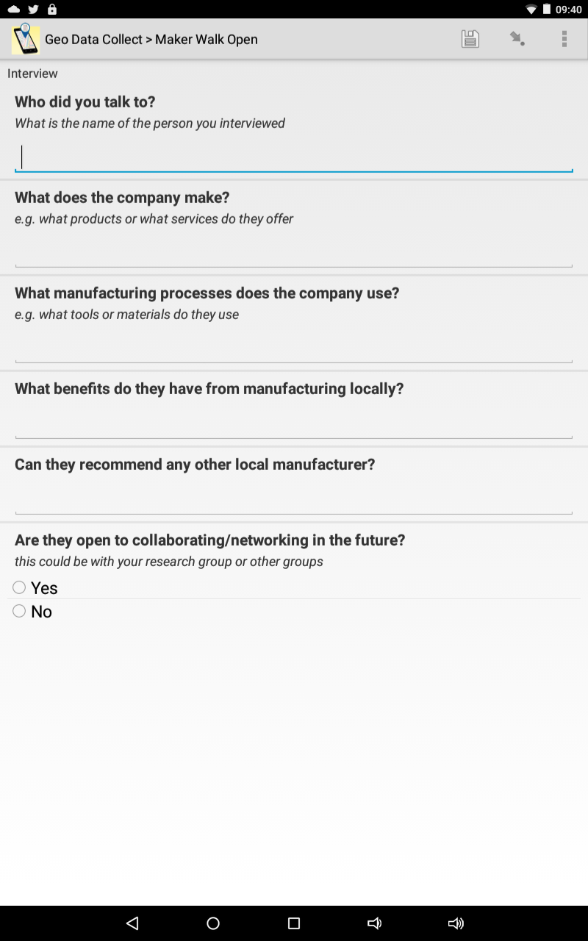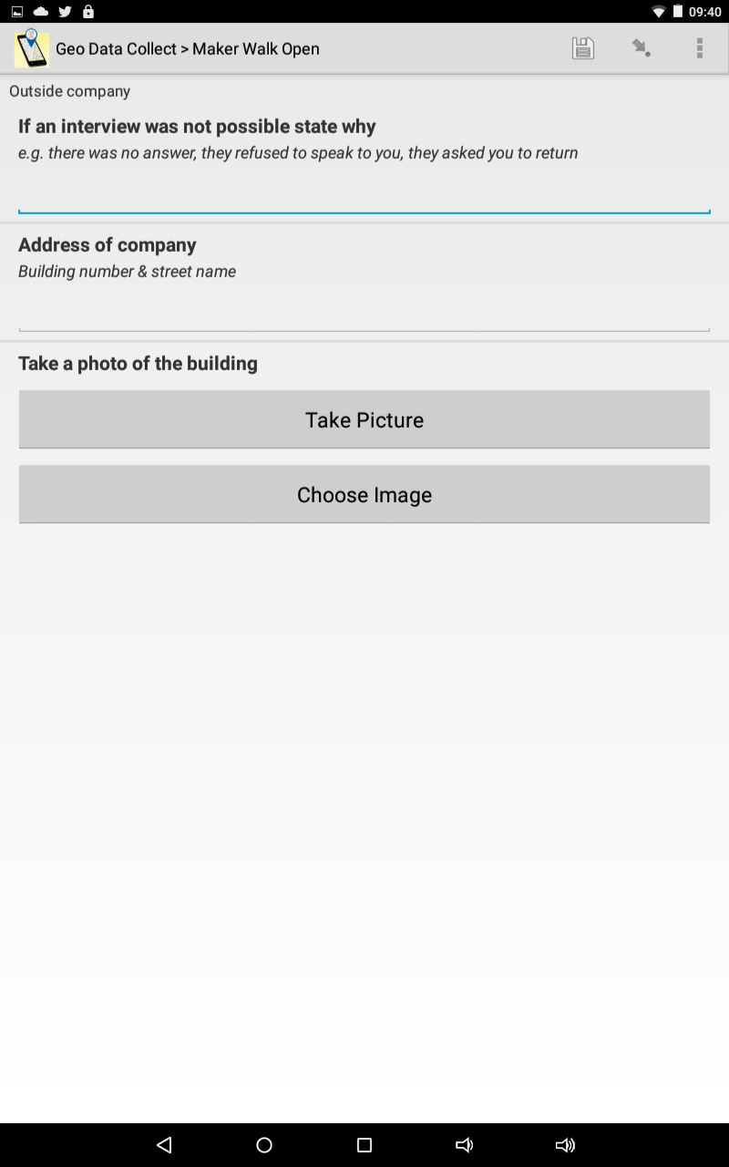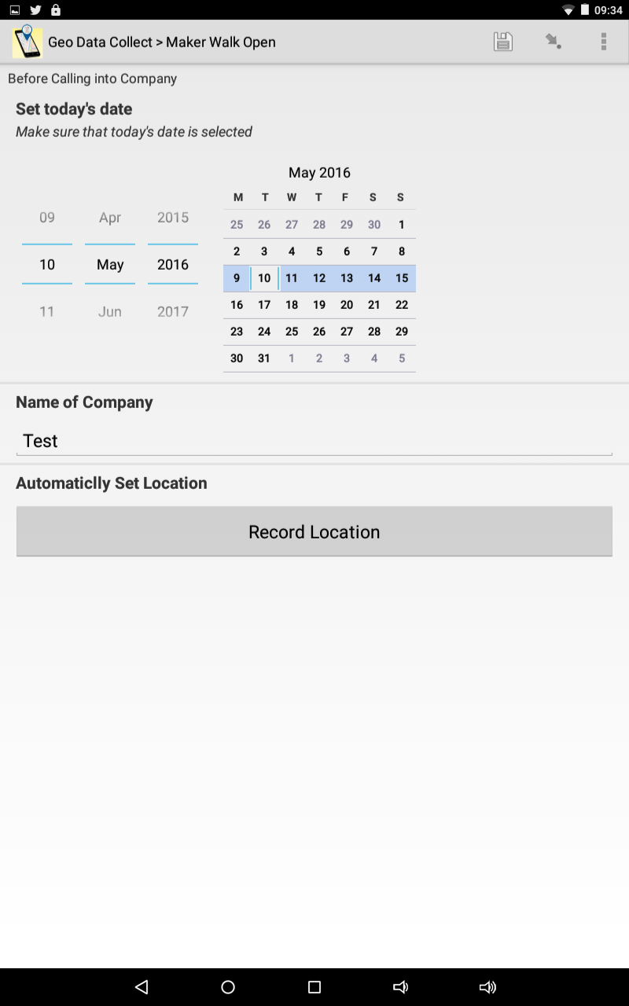Here is a copy of the survey forms we used on our Maker Walk

### ODK Aggregate

[ODK Aggregate](https://opendatakit.org/use/aggregate) is an online tool you can use to store and view all the information you collected.

Here are [instructions](https://opendatakit.org/use/aggregate) for installing ODK Aggregate on your computer.

ODK Aggregate requires a Gmail account as you will need to install an App Engine cloud. You will also need to have [Java 7](https://java.com/en/download/) or higher installed on your computer.

When you have installed ODK Aggregate you will be able to access it through your own customised ‘xxx[.appspot.com](https://my-app-id.appspot.com/)’ page. You will need to enter the details of this appspot.com into your ODK collect form to ensure the data is uploaded to the right place.

Here are some detailed [instructions](https://www.google.co.uk/earth/outreach/tutorials/odk_aggregate.html) on how to use ODK Aggregate.

### Exporting data from ODK Aggregate

Although you can do some simple data visualisation in ODK Aggregate it is best to export the data through three different file formats

##### CSV file which can be opened in a spreadsheet like MS Excel

##### KLM file that displays geographic data

##### JSON that can be accessed through a text editor

#### Mapping

Mapping the results of your Maker Walk is a great way to visualise the manufacturing activity in your area. Here is an example of the interactive [Maker Map](http://u.osmfr.org/m/84019/) we created from our Maker Walk in Bristol.

[UMap](http://umap.openstreetmap.fr/) is a very simple mapping program you can use. All you need to do is upload your exported CSV file into the map. You can alter the CSV file in a spreadsheet to make sure the map contains only the relevant information and to change the column headings so the data is mapped correctly.

Here are [instructions](http://wiki.openstreetmap.org/wiki/UMap/Guide) on how to create a map in UMap.

## 

You can live stream the data collected on the Maker Walk which may require technical skills. You will need to combine the follow instructions to achieve this

1. <https://opendatakit.org/use/aggregate/data-transfer/#Publishing>
2. <http://www.mappa-mercia.org/2014/09/creating-an-always-up-to-date-map.html>

## Redistributed Manufacturing in a Resilience and Sustainable City (RDM|RSC)

This guide was developed under the [RDM|RSC](http://www.rdmrsc.org.uk/) network which is funded by the [Engineering and Physical Sciences Research Council.](https://www.epsrc.ac.uk/) This Maker Walk guide was created in partnership between [School of Management](http://www.bath.ac.uk/management/) at the University of Bath and [The Systems Centre](http://www.bristol.ac.uk/eng-systems-centre/) at University of Bristol.

Lead Author & Lead Walker: [Jude Sherry](https://uk.linkedin.com/in/judesherry), University of Bath

Lead Academics: Professor [Mike Lewis](http://www.bath.ac.uk/management/faculty/mike_lewis.html), University of Bath

Professor [Chris McMahon](http://www.bristol.ac.uk/engineering/people/chris-a-mcmahon/index.html), University of Bristol

The RDM|RSC is one of six networks funded by the [EPSRC](https://www.epsrc.ac.uk/) that are performing research on redistributed manufacturing. The focus of this network is on the move to smaller-scale local manufacturing for Bristol and the surrounding region.

 [rdm](http://www.rdmrsc.org.uk/) Logo of the EPSRC, the Engineering and Physical Sciences Research Council Bristol uni

## Acknowledgments

The Maker Walk would not have been possible without the great help from the walking team.

Walking Team: [James Throup](https://www.linkedin.com/in/jamesthroup), University of Bristol

[Frank O’Connor](https://www.linkedin.com/in/frank-o-connor-64949411), Anois

[Lee Hutchinson](https://www.linkedin.com/in/lee-hutchinson-7252b212), M Shed

## Safety Notice

This guide does not need to be followed explicitly and we advise you to use your own approaches and common sense, especially to ensure your own and your walking team’s safety.

Walking is a great way to get exercise, get fresh air and see your city with new eyes. When undertaking any physical activity be fully responsible for you own safety and do not act in a manner that may jeopardize the safety of others.  If a walker has any doubts about their ability on a walk it is always advisable to err on the side of caution.

We highly recommend that you do not conduct any of the Maker Walk alone. If you do not feel comfortable in the surrounding environment, please do not continue with your walk. Likewise, if you are comforted by any dismissive or aggressive behaviour please simply walk away.